
PTO General Membership Update
December 2025

BUDGET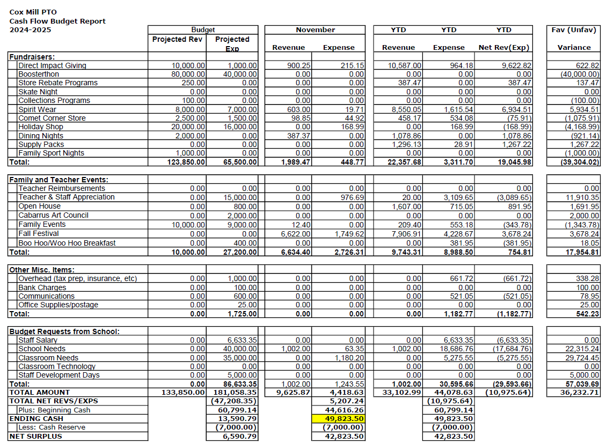

BUDGET

Incoming Funds:
-Direct Impact Giving (DIG)
-Penny Wars
-Fall Festival
-Tattoo Party
-Bingo Night
-Collections Programs (Harris Teeter Together In Education, BoxTops for Education, Lowes Foods Cart 2 Class)
-Spirit Wear
-Comet Corner
-Dining Nights (Sweet Frog, Domino’s, Freddy’s, Chick Fil A, BJ’s Crazy Mason)
-Family Nights (Hornets, Chuck E Cheese)

Outgoing Funds:
-Monthly Teacher/Staff Appreciation
November: School Psychologist Day & Substitute Recognition
December: Coffee Truck
-School Needs
-School Dance Deposits
-Staff Grant Requests: air dry modeling clay, musical rug, privacy folders, electric staplers, intervention program storage containers, 4th grade book club class set, professional book study books for teachers, new NC state flag,and Beebots for digital and classroom learning.

FUNDRAISING - DIRECT IMPACT GIVING
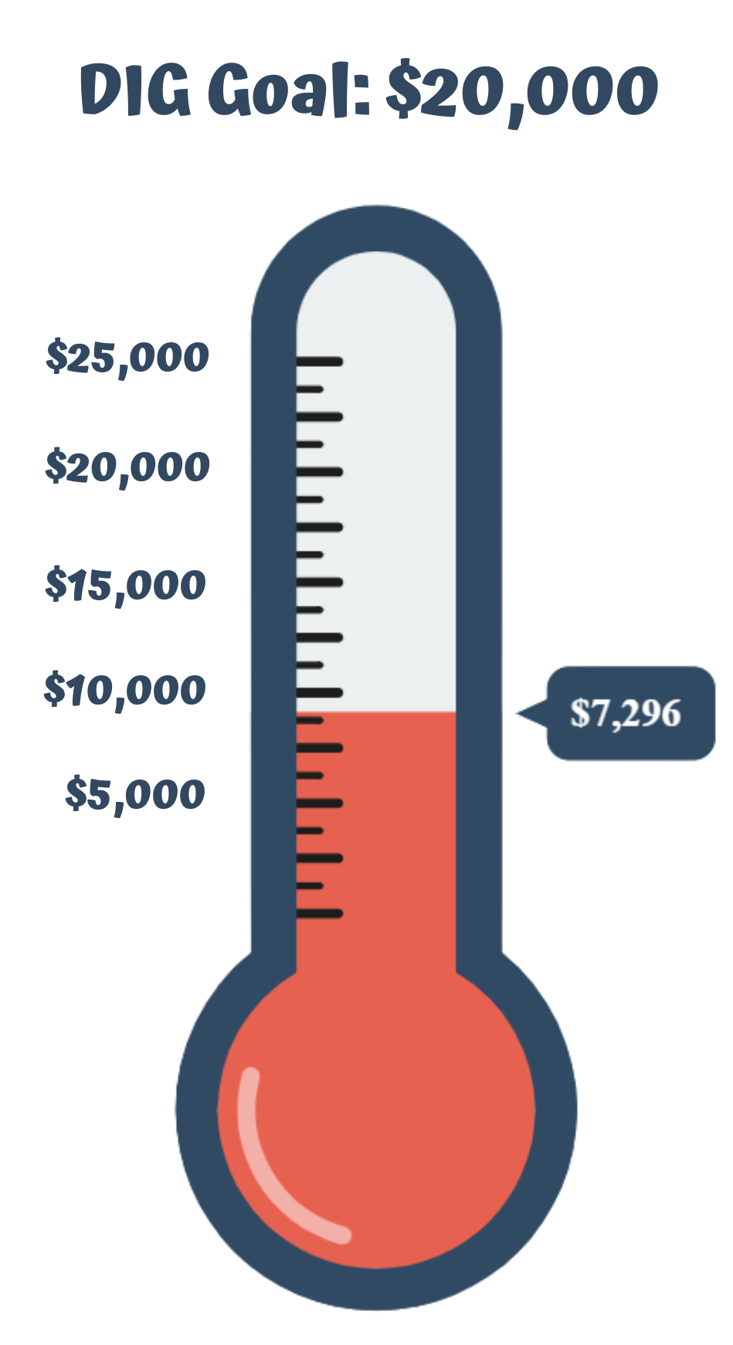
Direct Impact Giving funds will help support
(including but not limited to):

Staff Development & Appreciation
Teacher Grant Requests
Classroom needs
School Needs
(100% of these donations stay with the school)
FUNDRAISING: CONTINUOUS PROGRAMS



VOLUNTEER OPPORTUNITIES

Any questions regarding volunteering, please email
volunteers@coxmillpto.org
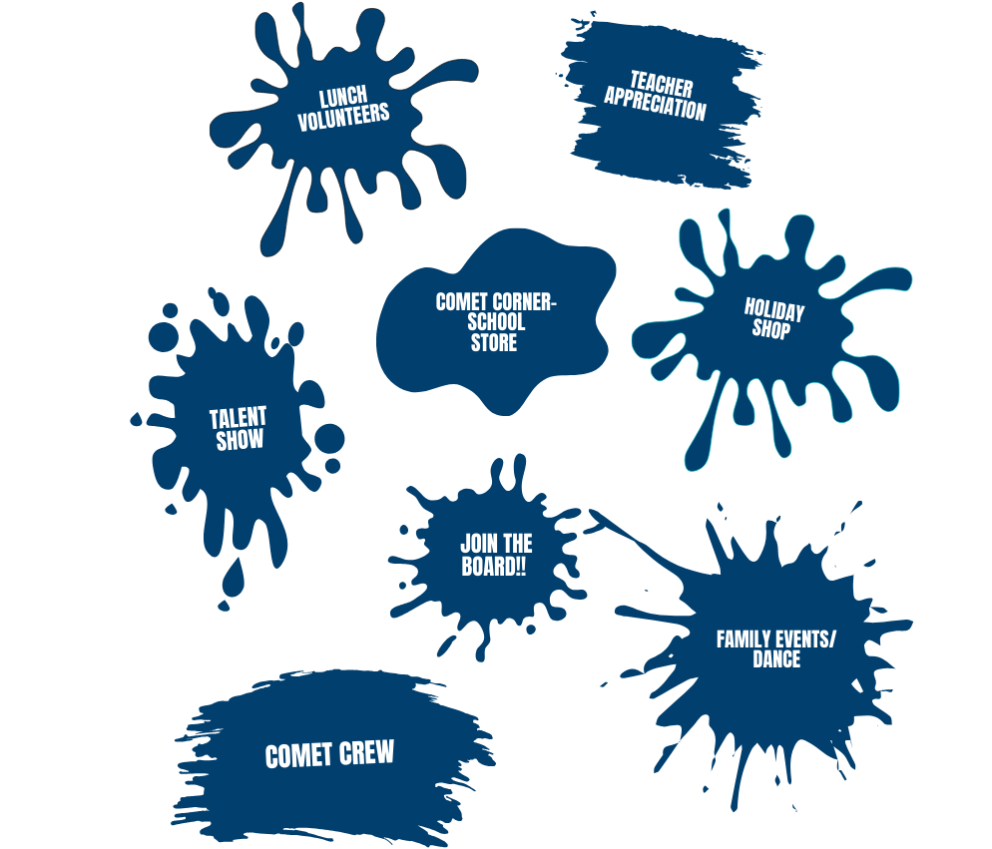
All volunteers will need to have an updated background screening which can be done at https://securevolunteer.com/Cabarrus-County-Schools/home
JOIN THE BOARD

Open Positions for 2026-2027

Vice President

Secretary

Treasurer

Family Events Co-Chair

Volunteer Coordinator

5th Grade Talent Show Chair

Teacher Appreciation Luncheon Chair

UPCOMING EVENTS

December
1– Coffee Truck - Teacher Appreciation Event
1-12 – Holiday Shop
9– Chick Fil A Dining Night
16– Domino’s Dining Night
20-Jan 4 – Winter Break

January
7 - Comet Corner All Grades
11 – Charlotte Checkers
14 – Comet Corner All Grades
19 – No School
20 – Domino’s Dining Night
21 – Comet Corner All Grades
26 – Pippa’s Dining Night
28 – Comet Corner All Grades
30 – All Pro Dad’s Meeting

February
4 – Comet Corner All Grades
6 – Souper Bowl Luncheon- Teacher Appreciation Event
10 – Bring a Stuffie Day
11– Comet Corner All Grades
16 – Panda Express Dining Night / No School
17 – Domino’s Dining Night
18– Comet Corner All Grades
21– Glow Dance Family Event
25– Comet Corner All Grades
27 – All Pro Dad’s Meeting


PTO COMMUNICATION

www.coxmillpto.org


www.facebook.com/CoxMillElemPTO


coxmillpto



communications@coxmillpto.org

2025-2026 PTO BOARD

President – Hope Basher
Vice President –Alicia Oats
Treasurer –Christy Parrott
Secretary – Jaime Manuel
VP’s of Fundraising – Chrissy Mann & Bobana Breen
Communications Director – Anna Bean
Volunteer Coordinator – Brittany Raymer
Family Events – Carrie Harris & Monica Johnson
Community Liaison – Swati Misra & Rhiannon Engelka
Teacher Appreciation – Becky Gould & Morgan Lofty

Questions: email president@coxmillpto.org

