
PTO General Membership Update
September 2025

BUDGET
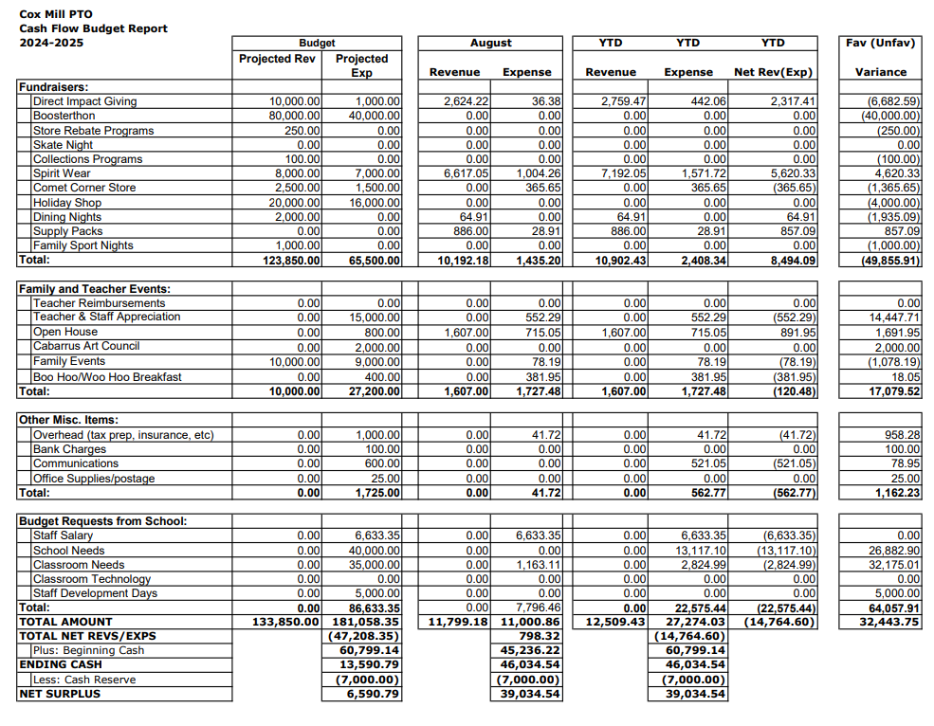

BUDGET

Incoming Funds:
-Direct Impact Giving (DIG)
-Stuffie Hotel
-Fast Pass Auction
-Collections Programs (Harris Teeter Together In Education, BoxTops for Education, Lowes Foods Cart 2 Class)
-Spirit Wear
-Comet Corner
-Dining Nights (Abbott’s, Domino’s, Jason’s Deli)
-Family Nights (Urban Air, Chuck E Cheese, Jocko’s)
-Supply Packs

Outgoing Funds:
-Monthly Teacher/Staff Appreciation
August: Welcome Breakfast, Staff Shirts
September: Rico’s Acai Bowls & Smoothies
October: Spooky Salads
-School Needs
-Staff Grant Requests: play rights for drama club, small group chairs, custodian appreciation gifts including water bottles and tee shirts, canvas tote bags, classroom organizational bins, soccer goals for upper playground, outdoor storage bins and gaga balls, colorful rug for music class, letterland sound cards, air dry clay for science, play based storage bins & recording buttons.

FUNDRAISING - DIRECT IMPACT GIVING
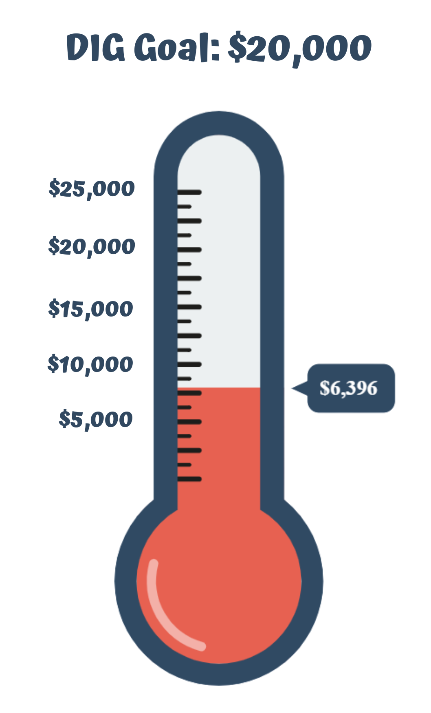
Direct Impact Giving funds will help support
(including but not limited to):

Staff Development & Appreciation
Teacher Grant Requests
Classroom needs
School Needs
(100% of these donations stay with the school)
FUNDRAISING: CONTINUOUS PROGRAMS

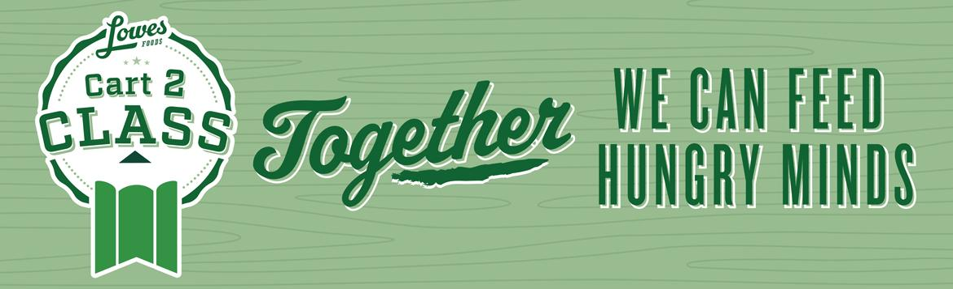

VOLUNTEER OPPORTUNITIES

Any questions regarding volunteering, please email
volunteers@coxmillpto.org
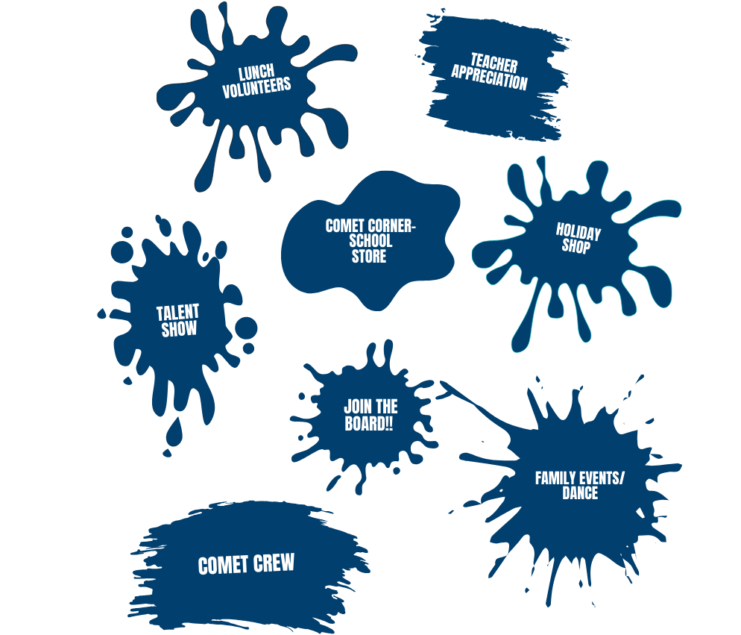
All volunteers will need to have an updated background screening which can be done at https://securevolunteer.com/Cabarrus-County-Schools/home
UPCOMING EVENTS

September
3 – Comet Corner All Grades
5 – Stuffie Hotel
5 – CMES/CMHS Tailgate
16 – Domino’s Dining Night
17 – Comet CornerAll Grades
22 – Urban Air Family Night
25 – PTO Interest Meeting & Curriculum Night
26 – All Pro Dad’s Meeting
26 – Panera Dining Night

October
1 - Comet Corner All Grades
6 – 9 Penny Wars
9 – Freddy’s Dining Night
12 – Jocko’s Family Night
15 - Comet Corner All Grades
21 – Domino’s Dining Night
23 – Bingo Night
24 – Sweet Frog Dining Night
31 - Spooky Salads - Teacher Appreciation

November
2 – Fall Festival
4 – Crazy Mason Dining Night
5 – Comet Corner All Grades
7 – Chuck E Cheese Family Night
18 – Domino’s Dining Night
19 – Comet Corner All Grades
22 – Hornets Spirit Night
23 – Bingo Night
24 – Sweet Frog Dining Night
31 - Spooky Salads - Teacher Appreciation Event

PTO COMMUNICATION


www.coxmillpto.org


www.facebook.com/CoxMillElemPTO


coxmillpto



communications@coxmillpto.org

2025-2026 PTO BOARD

President – Hope Basher
Vice President –Alicia Oats
Treasurer –Christy Parrott
Secretary – Jaime Manuel
VP’s of Fundraising – Chrissy Mann & Bobana Breen
Communications Director – Anna Bean
Volunteer Coordinator – Brittany Raymer
Family Events – Carrie Harris & Monica Johnson
Community Liaison – Swati Misra & Rhiannon Engelka
Teacher Appreciation – Becky Gould & Morgan Lofty

Questions: email president@coxmillpto.org

